RETURNS: CM DEPARTMENT
In July 2025, 191 leads with CC as an issue originator were replaced across 12 campaign blocks. The graphs below showcase the monthly Stats for replaced leads due to CC fault in terms of unique CID and return Cases.
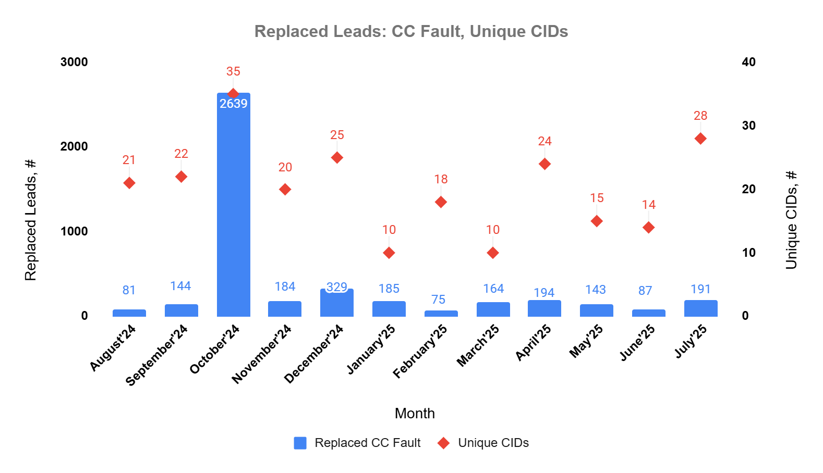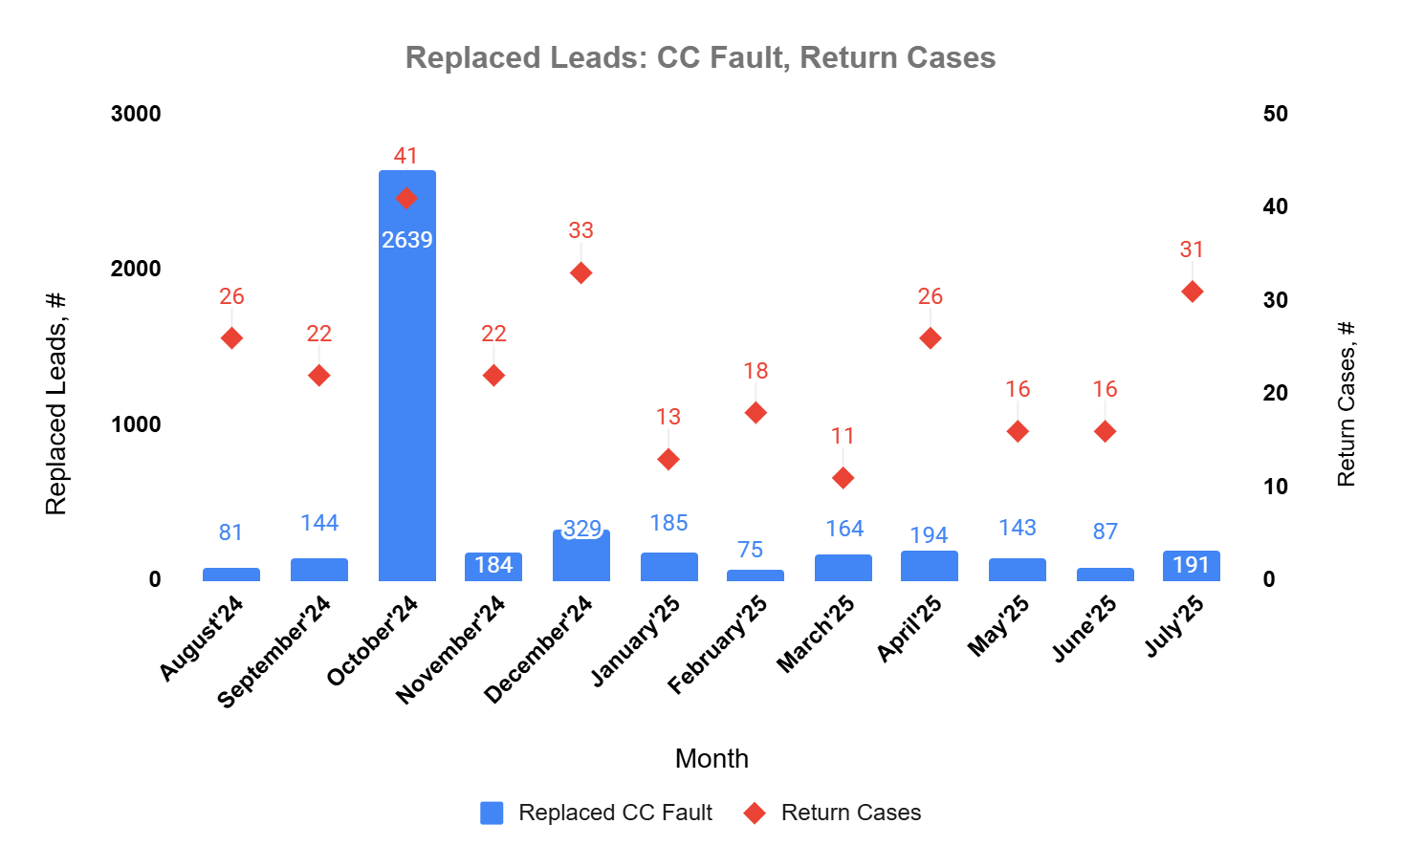
July 2025 represented a sharp increase for the CM department, with 191 returns, more than double June’s 87. The number of impacted blocks also grew (7 → 12), and the distribution of issues shifted, job function and industry mismatches climbed.
CM Department Returns Distribution - July`25
Reason Detailed | Replaced LD: CC Fault | Unique CIDs
CC: Other | 92 | 4
CC: Job Function doesn't fit | 49 | 14
CC: Industry doesn't fit | 29 | 5
CC: Employee size doesn't fit | 8 | 1
CC: Contact's GEO doesn't fit | 5 | 1
CC: Company/Lead is in SUP | 2 | 2
CC: Criteria Expansion | 2 | 1
CC: Not acceptable answer for CQ | 2 | 1
CC: Job Level doesn't fit | 1 | 1
CC: Not correct asset | 1 | 1
Total | 191 | 31
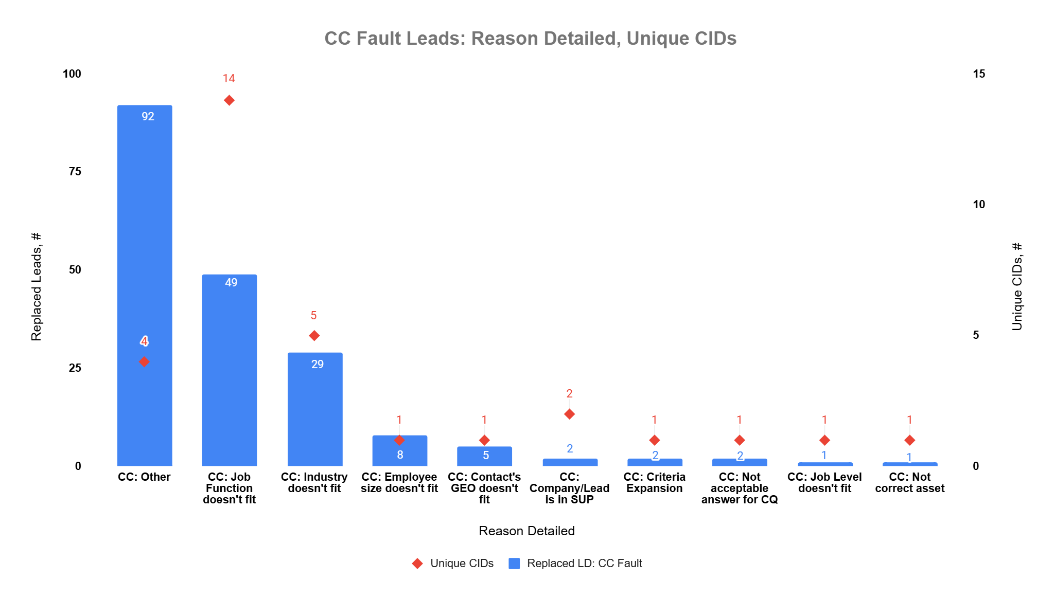
- “Other” surged as the top category with 92 returns, a new leading issue not prominent in June, largely concentrated in DU and DC blocks
- “Job Function doesn’t fit” rose to 49 cases, although down from June’s 56 in share, it remained a major source of returns spread across many CIDs
- “Industry doesn’t fit” increased to 29 cases, reversing the downward trend observed in June (11), showing targeting criteria challenges resurfacing
- New categories appeared in July, including “Employee size doesn’t fit” (8) and “Criteria Expansion” (2), reflecting broader inconsistency in validation
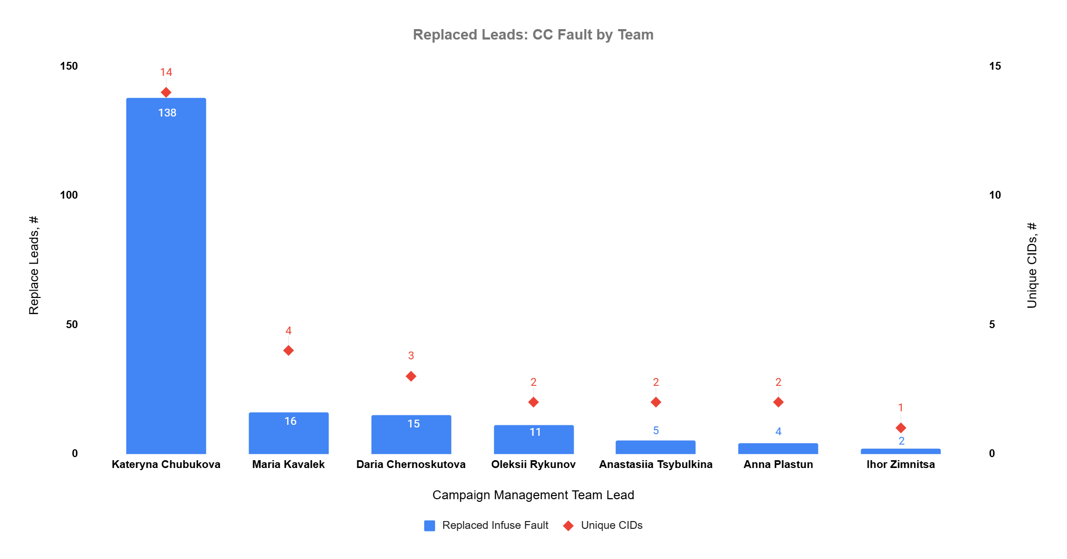

CC TL | CC | CID | Reason Detailed | Replaced Infuse Fault
Kateryna Chubukova | Buket Irem Bahadir | DU66255 | CC: Other | 77
Kateryna Chubukova | Yehor Mezherytskyi | DU65857 | CC: Industry doesn't fit | 18
Kateryna Chubukova | Yehor Mezherytskyi | SU64698 | CC: Industry doesn't fit | 1
Kateryna Chubukova | Maryna Kalynichenko | GU65117 | CC: Job Function doesn't fit | 6
Kateryna Chubukova | Maryna Kalynichenko | GU66879 | CC: Contact's GEO doesn't fit | 5
Kateryna Chubukova | Maryna Kalynichenko | GU66882 | CC: Industry doesn't fit | 5
Kateryna Chubukova | Maryna Kalynichenko | GU66315 | CC: Job Function doesn't fit | 1
Kateryna Chubukova | Kateryna Chubukova | GU62819 | CC: Employee size doesn't fit | 8
Kateryna Chubukova | Kateryna Chubukova | GU62819 | CC: Job Function doesn't fit | 2
Kateryna Chubukova | Kateryna Chubukova | GU62819 | CC: Company/Lead is in SUP | 1
Kateryna Chubukova | Iryna Golovko | KU65596 | CC: Job Function doesn't fit | 5
Kateryna Chubukova | Iryna Golovko | DU66858 | CC: Job Function doesn't fit | 2
Kateryna Chubukova | Iryna Golovko | SU65022 | CC: Other | 1
Kateryna Chubukova | Alina Volynchuk | XU66961 | CC: Job Function doesn't fit | 3
Kateryna Chubukova | Nataliia Yushchenko | KU65602 | CC: Job Function doesn't fit | 2
Kateryna Chubukova | Nataliia Yushchenko | DU66113 | CC: Job Function doesn't fit | 1
Maria Kavalek | Maryna Zhaha | DA64989 | CC: Job Function doesn't fit | 11
Maria Kavalek | Maryna Zhaha | DA64989 | CC: Criteria Expansion | 2
Maria Kavalek | Varvara Yevsiukova | DA66377 | CC: Job Function doesn't fit | 1
Maria Kavalek | Varvara Yevsiukova | DA66538 | CC: Company/Lead is in SUP | 1
Maria Kavalek | Maria Kavalek | GU67005 | CC: Job Level doesn't fit | 1

Daria Chernoskutova | Tetiana Yakimovich | DC66444 | CC: Other | 10
Daria Chernoskutova | Tetiana Yakimovich | XR67043 | CC: Industry doesn't fit | 1
Daria Chernoskutova | Daria Chernoskutova | XR66986 | CC: Industry doesn't fit | 4
Oleksii Rykunov | Katerina Hubarieva | HC65157 | CC: Job Function doesn't fit | 7
Oleksii Rykunov | Darya Shyrokava | SA65342 | CC: Other | 4
Anastasiia Tsybulkina | Tetiana Kaspriak | KU65600 | CC: Job Function doesn't fit | 4
Anastasiia Tsybulkina | Tamar Sujashvili | MVF65957 | CC: Not correct asset | 1
Anna Plastun | Aysel Samadova | DA65311 | CC: Job Function doesn't fit | 2
Anna Plastun | Valeriia Zhaha | DA66673 | CC: Job Function doesn't fit | 2
Ihor Zimnitsa | Sofia Maliukina | DF66685 | CC: Not acceptable answer for CQ | 2

Team-Level Observations
- Kateryna Chubukova Team (DU, GU blocks) dominated July’s returns, driving 77 “Other” cases in DU and additional mismatches in GU (industry, job function, GEO, employee size)
- Maria Kavalek Team (DA, GU blocks) logged 14 job function mismatches, plus SUP (1), Criteria Expansion (2), and Job Level (1), showing diverse but recurring issues.
- Vladyslav Mozghovyi Team (XR block) added industry mismatches (5 total) and smaller contributions to “Other”.
- Daria Chernoskutova Team (DC, XR) contributed 10 “Other” cases in DC and industry mismatches in XR.

The chart and graph illustrate the distribution of returned leads across the number of unique CIDs by teams.
The stats were compiled following the most recent team shuffle.

